**Chapter 1 : Introduction**

**Chp 1 -- One Hop Transmission Delay:**

**COMPUTING THE ONE-HOP TRANSMISSION DELAY**

Consider the figure below, in which a single router is transmitting packets, each of length *L* bits, over a single link with transmission rate *R* Mbps to another router at the other end of the link.

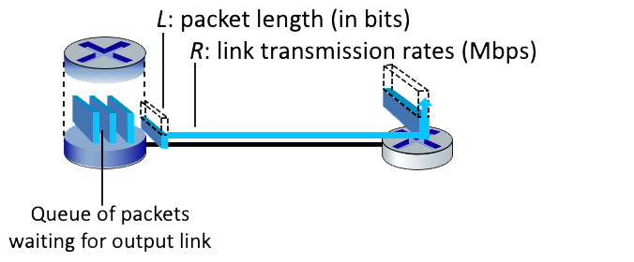

Suppose that the packet length is *L*= 12000 bits, and that the link transmission rate along the link to router on the right is *R* = 10 Mbps. Round your answer to two decimals after leading zeros

**QUESTION LIST**

1. What is the transmission delay?  
**D = L/R   
D = 12000 bits/10^6 bps = 0.0012s**

2. What is the maximum number of packets per second that can be transmitted by this link?  
**P = R/L  
P = 10^6 bps/12000 bits = 833 packets**

**Queueing Delay:**

**QUEUING DELAY**

Consider the queuing delay in a router buffer, where the packet experiences a delay as it waits to be transmitted onto the link. The length of the queuing delay of a specific packet will depend on the number of earlier-arriving packets that are queued and waiting for transmission onto the link. **If the queue is empty and no other packet is currently being transmitted, then our packet’s queuing delay will be zero. On the other hand, if the traffic is heavy and many other packets are also waiting to be transmitted, the queuing delay will be long.**

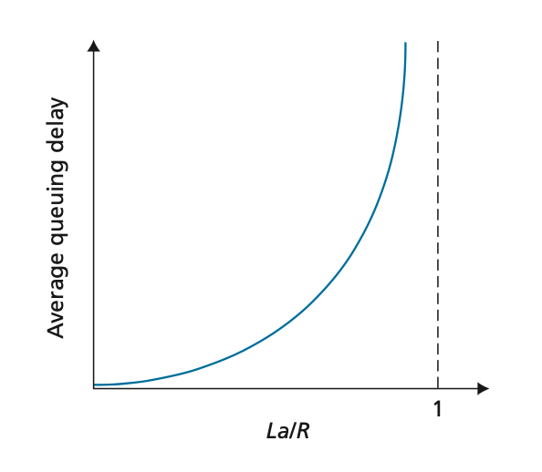

Assume a constant transmission rate of **R = 1100000 bps**, a constant packet-length **L = 3100 bits**, and **a** is the average rate of packets/second.

**Traffic intensity I = La/R**, and the queuing delay is calculated as **I(L/R)(1 - I) for I < 1.**

1 second == 1000 msec

**QUESTION LIST**

1. In practice, does the queuing delay tend to vary a lot? Answer with Yes or No  
**Yes, it can vary significantly. We use queue delay formulas to provide rough estimate. In real-life scenario it is much more complicated**.  
  
2. Assuming that a = 20, what is the queuing delay? Give your answer in milliseconds (ms)  
**Qd = I(L/R)/(1-I)*1000 = 0.0564*(3100/1100000)/(1-0.0564)*1000 = 0.17 ms**  
3. Assuming that a = 69, what is the queuing delay? Give your answer in milliseconds (ms)  
**La = 69 packets * 3100 bits = 213900  
I = 213900/1100000 = 0.1945  
L/R = 3100 bits / 1100000 bps = 0.002818 sec * 1000 = 2.818 ms**  
**Qd = I * L/R / 1 – I  
Qd = (0.1945 * 2.818) / (1-0.1945)   
Qd = 0.548101 / 0.8055 = 0.6804 ms**

**End-to-End Delay: (Transmission and Propagation Delay)**

**COMPUTING END-END DELAY (TRANSMISSION AND PROPAGATION DELAY)**

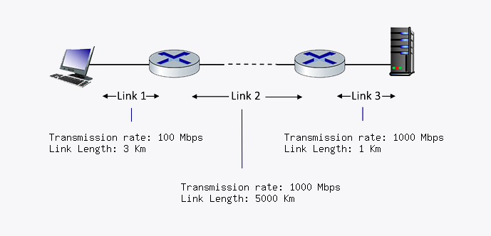Consider the figure below, with three links, each with the specified transmission rate and link length.

Assume the length of a packet **is 4000 bits**. The speed of light propagation delay on each link is **3x10^8 m/sec.** Round your answer to two decimals after leading zeros

**QUESTION LIST**

1. What is the transmission delay of link 1?  
**Td = L/R = 4000/100*10^6 = 1/25000 = 4*10^-5 = 0.00004 sec * 1000 = 0.04 ms**  
2. What is the propagation delay of link 1?  
**Pd = d/s = 3km/3*10^8 = 3*1000 / 3*10^8 = 3000 / 300000000 = 3/300000 = 1/100000 = 1*10^-5 sec = 0.00001 sec * 1000 = 0.01 ms**3. What is the total delay of link 1?  
**Total Delay = 0.00004 + 0.00001 = 0.00005 sec = 0.05 ms**  
  
4. What is the transmission delay of link 2?  
**Td = L/R*10^6 = 4000bits/1000*10^6 = 1/250000 * 1000 = 1/250 = 0.004 ms**  
5. What is the propagation delay of link 2?  
**Pd = d/s = 5000 * 1000 / 3*10^8 = 5000000 / 300000000 = 1/60 *1000 = 16.67**  
  
6. What is the total delay of link 2?  
**Total Delay = 0.004 + 16.67 = 16.674 ms**  
7. What is the transmission delay of link 3?  
**Td = L/R*10^6 = 4000/1000*10^6 * 1000 = 1/250000*1000 = 1/250 = 0.004 ms**  
8. What is the propagation delay of link 3?  
**Pd = d/s = 1*1000 / 3*10^8 * 1000 = 1/300000*1000 = 1/300 = 0.0033 ms**  
9. What is the total delay of link 3?  
**Total Delay = 0.004 + 0.0033 = 0.0073 ms**  
  
10. What is the total delay?  
**Total Delay = 0.0073 + 16.674 + 0.05 = 16.7313 ms**

**The IP Stack and Protocol Layering:**

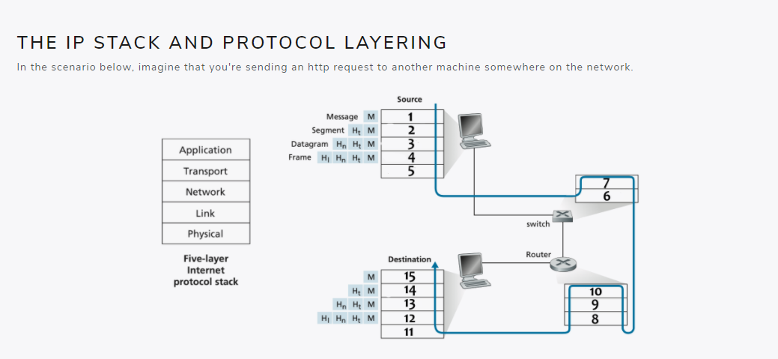

**QUESTION LIST**

1. What layer in the IP stack best corresponds to the phrase: 'handles the delivery of segments from the application layer, may be reliable or unreliable'  
**Transport Layer**  
  
2. What layer in the IP stack best corresponds to the phrase: 'handles messages from a variety of network applications'  
**Application Layer**  
3. What layer in the IP stack best corresponds to the phrase: 'passes frames from one node to another across some medium'  
**Link Layer**  
4. What layer in the IP stack best corresponds to the phrase: 'moves datagrams from the source host to the destination host'  
**Network Layer**  
5. What layer in the IP stack best corresponds to the phrase: 'bits live on the wire'  
**Physical Layer**  
6. What layer corresponds to box 1?  
**Application Layer**  
7. What layer corresponds to box 2?  
**Transport Layer**  
8. What layer corresponds to box 3?  
**Network Layer**  
9. What layer corresponds to box 4?  
**Link Layer**  
  
10. What layer corresponds to box 5?  
**Physical Layer**  
  
11. What layer corresponds to box 6?  
**Physical Layer**  
  
12. What layer corresponds to box 7?  
**Link Layer**  
  
13. What layer corresponds to box 8?  
**Physical Layer**  
  
14. What layer corresponds to box 9?  
**Link Layer**  
  
15. What layer corresponds to box 10?  
**Network Layer**  
16. What layer corresponds to box 11?  
**Physical Layer**17. What layer corresponds to box 12?  
**Link Layer**  
  
18. What layer corresponds to box 13?  
**Network Layer**  
  
19. What layer corresponds to box 14?  
**Transport Layer**  
20. What layer corresponds to box 15?  
**Application Layer**